Alexander Plekhanov
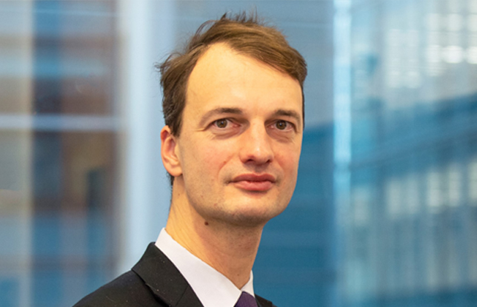
Alexander Plekhanov
Director for Transition Impact and Global Economics

Email
Alexander Plekhanov is a Director for Transition Impact and Global Economics at the EBRD Office of the Chief Economist.
He edits EBRD’s annual economic report, the Transition Report, and Regional Economic Prospects. He has worked on global macroeconomic issues as well as a country economist on a number of countries, including Belarus, Kazakhstan, Mongolia and Russia.
Prior to joining the Bank, Alexander worked as an economist at the International Monetary Fund.

